**Math 120**

**Test 1A**

**Student Name: _______________________________________ Student Number: ______________________**

**Directions:**

* SHOW ALL YOUR WORK OR JUSTIFICATION FOR ANSWERS *ON THE TEST*. Scrap paper is sometimes hard to read and I want to give you partial credit!
* Simplify all answers.
* Round answers as indicated.
* Include units with final answers.

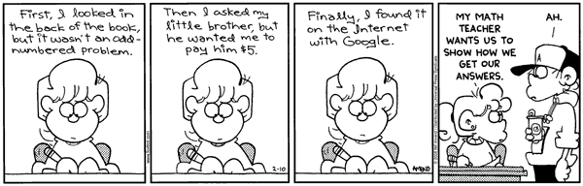

* 1. Determine if the following are functions. Answer YES or NO in the blank.

1.  __________________
2. {(4,2), (3, 4), (5, 9), (3, 2)} __________________

1. x=4 __________________
2.  __________________
3. 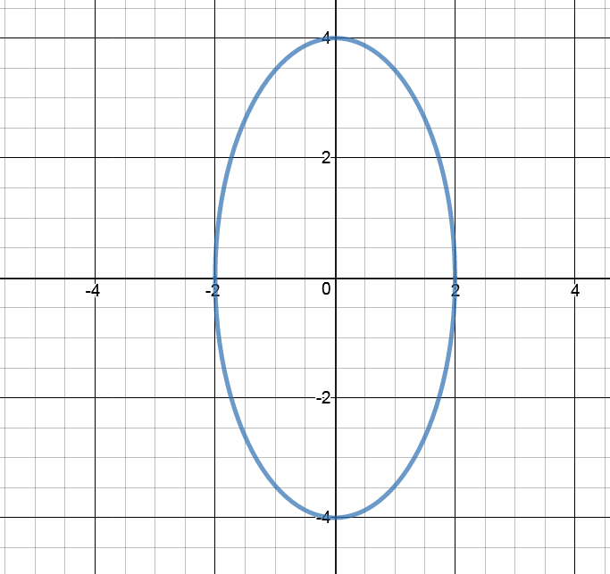 __________________
   1. Evaluate the function at the given values of the independent variable and simplify.



1.  a.______________________
2.  b.______________________
3.  c.______________________

3. Use the graph below to find the following.

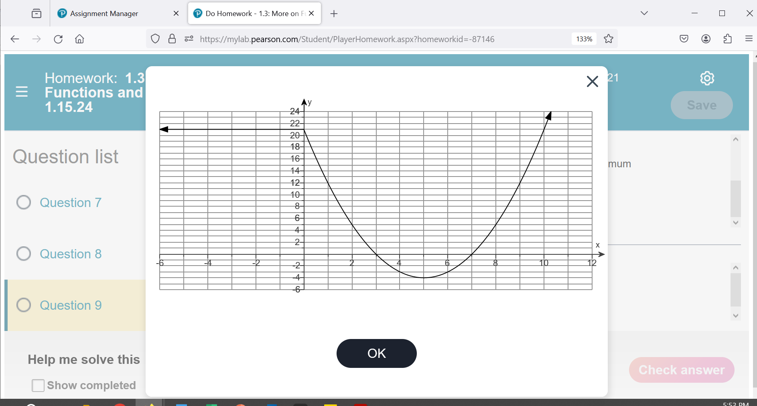

a. List the x-intercept(s), if any. If there aren’t any, say NONE. a.______________________

b. List the y-intercept(s), if any. If there aren’t any, say NONE. b.______________________

c. Find  c.______________________

d. For what value(s) of x is  d.______________________

e. State the domain in interval notation. e.______________________

4. Use the graph above to find the following.

f. State the range in interval notation. f.______________________

g. State the interval(s) on which *f* is increasing g.______________________

h. State the interval(s) on which *f* is decreasing h.______________________

j. The number at which *f* has a relative minimum j._______________________

k. The relative minimum of *f* k.______________________

5. a. A car was purchased for $22,500. The value of the car DECREASES by $3200 per year. Write a function that describes the value of the car *V* after *x* years.

a.______________________

b. In how many years will the car be worth $6500? b.______________________

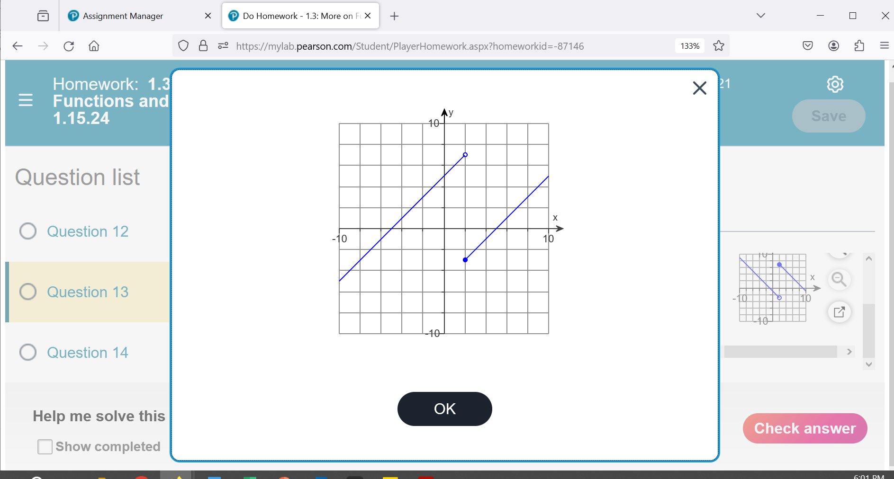

6. Use the piecewise function shown



a. Find 

__________________

b. Find 

__________________

7. Consider the linear function:

a. What is the slope of this line? a.______________________

b. Find , simplify the final answer. b.______________________

c. Construct and simplify the **difference quotient**. c.______________________

8. Find the equation of the line that goes through the point (6, -2) and has a slope of . Put your final answer in slope-intercept form.

______________________

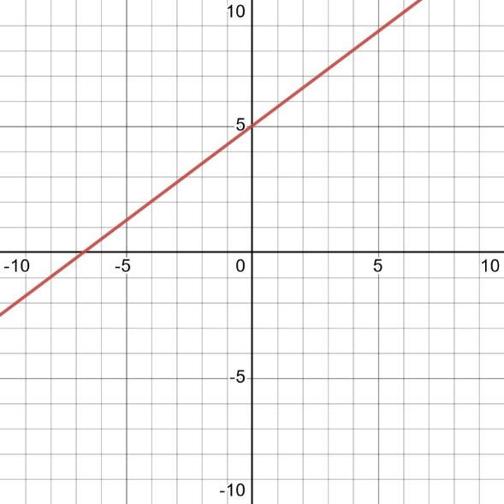9. Use the graph.

a. Select any two points on the graph and find the slope.

______________________

b. Using your information above, construct the equation for this graph. Put your final answer in slope-intercept form.

______________________

10. Refer to the figure below.

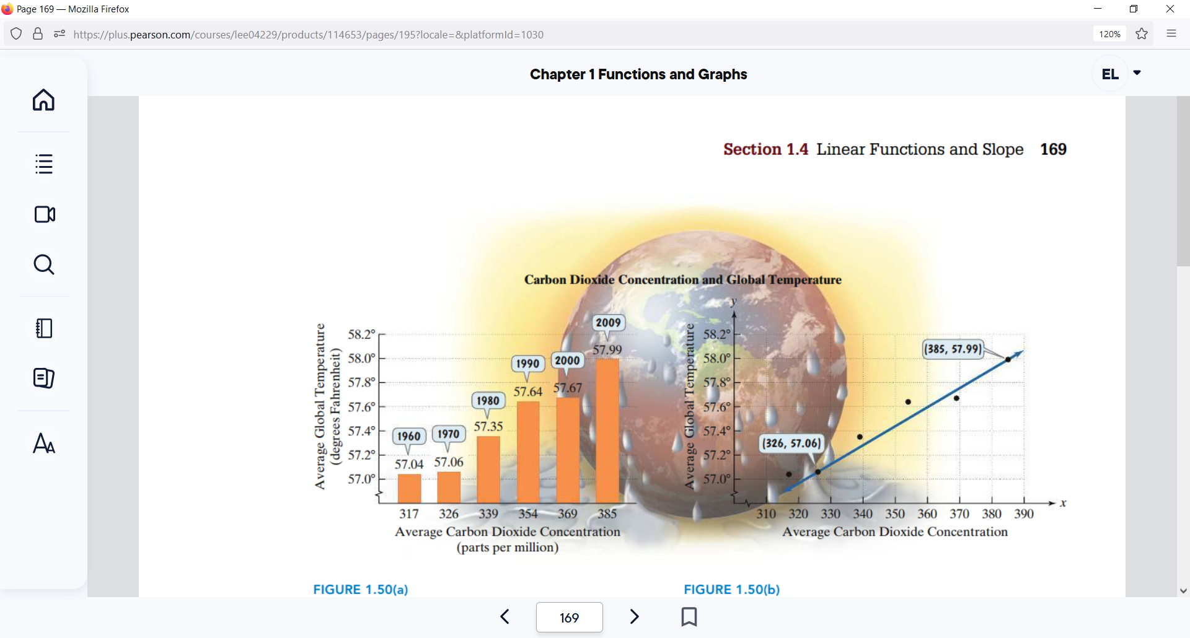

a. Find the slope between the two points given. Simplify and round to the nearest hundredth. Include units.

______________________

Parts per million

b. Interpret the slope in the context of the problem including units. Answer in at least one complete sentence.

________________________________________________________________________________________________________________________________________________________________________________________________________________________________________________________________________________________________________________________________________________

11. Find the equation of a line that is parallel to the line and passes through the

point (-8, -10). Put your final answer in slope-intercept form.

______________________

12. Find the equation of a line that passes through the point (2,5) and the slope is 0.

______________________

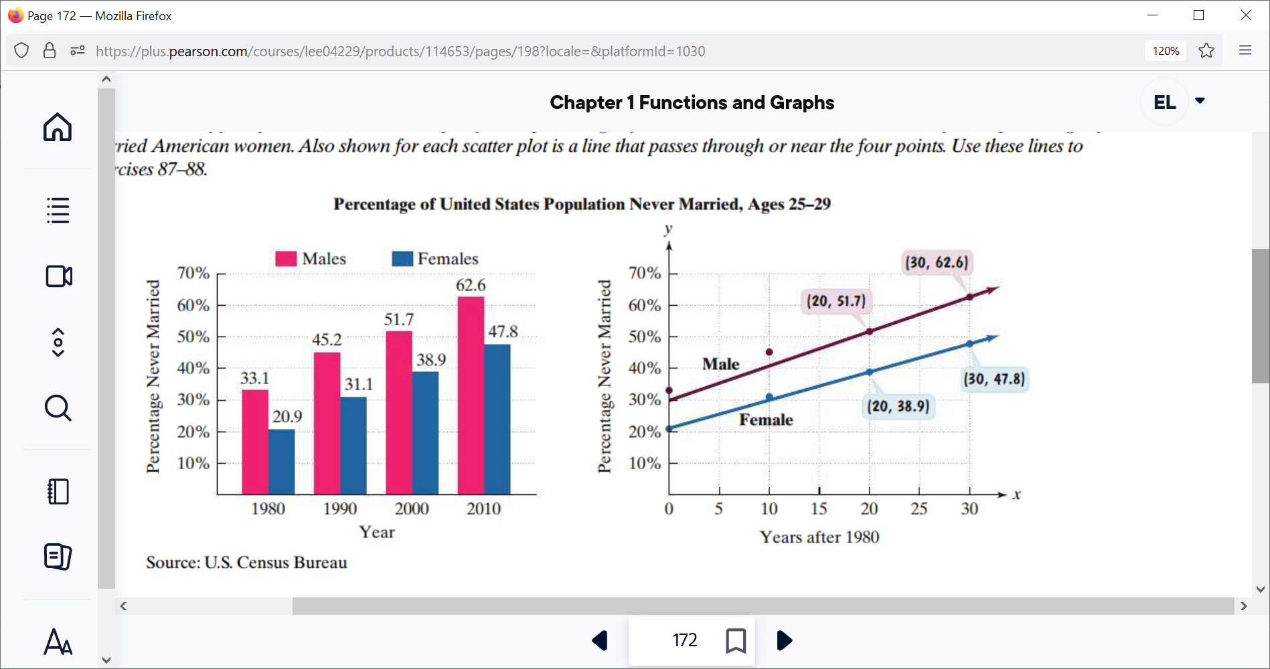13. Use the **top line for men** shown on the model to develop a model of the percentage of never married American males ages 25-29.

a. Use the two points whose coordinates are shown by the balloons to find the equation of the line that models the percentage of never-married American males ages 25-29, *y,* when it is *x* years after 1980. Use function notation. Put your final answer in slope-intercept form.

a.______________________

b. Use the linear function you made above to predict the percentage of never-married American males, ages 25-29, in 2015. (This is how many years after 1980…) Include units and do not round the answer.

b.______________________

14. Suppose that a ball is thrown vertically upward from the ground. The height of the ball above the ground as a function of time is given by the equation:  where  is the height of the ball in meters and *t* is the time in seconds.

* 1. What is the height of the ball above the ground after t=1 seconds? Include units and do not round the answer.

a.______________________

b. What is the height of the ball above the ground after t=2 seconds? Include units and do not round the answer.

b.______________________

c. Using the information you found in part *a* and *b*, find the AVERAGE RATE OF CHANGE between x1=1 second and x2= 2 seconds

c.______________________

15. Find the domain of the given function. Write your answer in interval notation.



______________________

16. Find the domain of the given function. Write your answer in interval notation.



______________________

17. Given  and 

a. Find  and simplify

a.______________________

b. Find  and simplify

b.______________________

18. Using the functions from the previous question, find the following:

a. Find 

a.______________________

b. Find 

b.______________________

19. Decompose the function that follows such that . Be sure to label which function is and which is . 

______________________

______________________

20. Consider the function that is one-to-one.

a. Find an equation for 

a.______________________

b. Use interval notation to give the domain of 

b.______________________

OPTIONAL EXTRA CREDIT QUESTION:

Construct and simplify the difference quotient for the following function:



______________________

**Formula Sheet: Math 120**

**Straight Line**

Slope Intercept form Point-slope form Slope

  

**Difference Quotient Quadratic Formula**

 

**Logarithms**

  

**Distance**:  **Midpoint**: 

**Circle**: 

**Quadratic Function**

, Vertex =  , Vertex = 

**Compound Interest**:  **Continuous Compound Interest:** 

**Arithmetic Sequence Geometric Sequence**

 Finite:  

 Infinite: , 

**Even function Odd function**

 